1. Adding new Matrix Element to Matrix

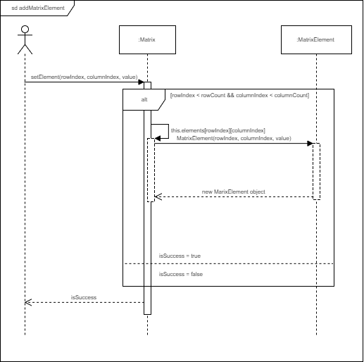

1. Set Matrix Elements value to zero (Matrix element cannot be removed. It can be set to zero.)

